ACSL
American Computer Science League
2012 - 2013

Contest #4

Senior Division Solutions
1. 29
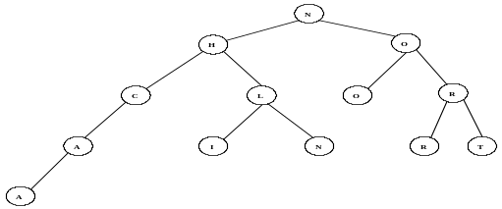
- Data Structures

The internal path length is:
2*1+4*2+5*3+1*4 = 29

2. A
2. Data Structures The construction is as follows: M, ME, MED, ED,
EDI, EDIT, EDITE, EDIT, DIT, DITR, DITRA, ITRA, TRA, TR, TRE,
TREA, TREAN, REAN, EAN, EANS, EANSE, ANSEA, NSEA
The next popped item is A since it ended as a stack.

3. Digital Electronics The circuit translates to: 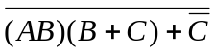
3. (0,0,1)
(0,1,1)
(1,0,1)
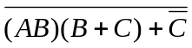 = 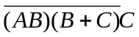 = 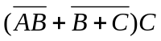
= 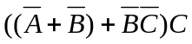 = 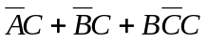 = 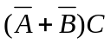
So
Therefore (0, 0, 1), (0, 1, 1), (1, 0, 1) make the circuit true.
- Digital Electronics Circuit translates 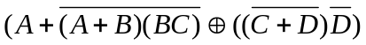
and simplifies to: 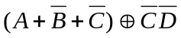
4. 6

 |  |  |  | 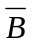 | 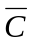 | 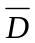 | 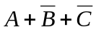 | 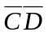 | 
0 | 0 | 0 | 0 | 1 | 1 | 1 | 1 | 1 | 0
0 | 0 | 0 | 1 | 1 | 1 | 0 | 1 | 0 | 1
0 | 0 | 1 | 0 | 1 | 0 | 1 | 1 | 0 | 1
0 | 0 | 1 | 1 | 1 | 0 | 0 | 1 | 0 | 1
0 | 1 | 0 | 0 | 0 | 1 | 1 | 1 | 1 | 0
0 | 1 | 0 | 1 | 0 | 1 | 0 | 1 | 0 | 1
0 | 1 | 1 | 0 | 0 | 0 | 1 | 0 | 0 | 0
0 | 1 | 1 | 1 | 0 | 0 | 0 | 0 | 0 | 0
1 | 0 | 0 | 0 | 1 | 1 | 1 | 1 | 1 | 0
1 | 0 | 0 | 1 | 1 | 1 | 0 | 1 | 0 | 1
1 | 0 | 1 | 0 | 1 | 0 | 1 | 1 | 0 | 1
1 | 0 | 1 | 1 | 1 | 0 | 0 | 1 | 0 | 1
1 | 1 | 0 | 0 | 0 | 1 | 1 | 1 | 1 | 0
1 | 1 | 0 | 1 | 0 | 1 | 0 | 1 | 0 | 1
1 | 1 | 1 | 0 | 0 | 0 | 1 | 1 | 0 | 1
1 | 1 | 1 | 1 | 0 | 0 | 0 | 1 | 0 | 1

5. LISP (CAR(CAR(CDR(REV(CDR ‘((2(1 2))(4 1 3)((2 1)3)4))))))
= (CAR(CAR(CDR(REV ‘((4 1 3)((2 1)3)4)))))
= (CAR(CAR(CDR ‘(4((2 1)3)(4 1 3)))))
= (CAR(CAR ‘(((2 1)3)(4 1 3))))
= (CAR ‘((2 1)3)) = (2 1)

5. (2 1)

